**KWAME NKRUMAH UNIVERSITY OF SCIENCE AND TECHNOLOGY**

**KUMASI**

**COLLEGE OF SCIENCE**

**DEPARTMENT OF COMPUTER SCIENCE**



**PROJECT PROPOSAL**

**TOPIC:**

**AI SENTIMENT ANALYZER EXTENSION USING NATURAL LANGUAGE PROCESSING**

**BY**

**BRIGHT KUMEDZRO: 4214420**

**SUPERVISOR:**

**DR. NAJIM USSIPH**

**TABLE OF CONTENT**

## **CHAPTER 1: INTRODUCTION**

## **CHAPTER 2: REVIEW OF EXISTING SYSTEMS**

## **CHAPTER 3: METHODOLOGY**

## **CHAPTER 4: IMPLEMENTATIONS AND RESULTS**

## **CHAPTER 5: FINDINGS AND CONCLUSIONS**

# **INTRODUCTION**

## **Problem Statement**

In today's digital landscape, the abundance of online content presents a challenge for individuals and businesses to effectively understand and interpret the sentiments expressed within textual data. Without efficient tools to analyze sentiment in real-time, users are faced with the daunting task of manually sifting through vast amounts of information, hindering their ability to make informed decisions and extract valuable insights.

This project aims to address this challenge by developing an AI Sentiment Analyzer browser extension, providing users with a seamless and intuitive solution for extracting sentiment analysis directly within their web browsing experience. The problem statement revolves around the lack of accessible, real-time sentiment analysis tools tailored for browsing activities, resulting in inefficiencies, missed opportunities, and a lack of timely insights for decision-making across various domains and industries.

**Key issues include the absence of:**

* Real-time sentiment analysis capabilities directly integrated into web browsers.
* User-friendly interfaces and customizable features for seamless interaction and interpretation of sentiment analysis results.
* Comprehensive sentiment analysis solutions that cater to diverse user needs and contexts, from marketers and customer service representatives to financial professionals and everyday internet users.
* Privacy-focused and secure sentiment analysis tools that prioritize the protection and confidentiality of user data while delivering actionable insights from online content.

## **Aim of the project**

The aim of the project is to develop a browser extension equipped with AI-based sentiment analysis capabilities, enabling real-time analysis of textual content encountered during web browsing. This extension aims to empower users with valuable insights, enhance decision-making processes, and revolutionize the way individuals and businesses interact with online content across diverse industries.

## **Specific Objectives of the project**

The objectives of the AI Sentiment Analyzer as a browser extension are as follows:

* **Real-time Sentiment Analysis:** Develop a system capable of analyzing sentiment in real-time as users browse the web, providing instantaneous feedback on the emotional tone of textual content encountered online.

* **Accurate Sentiment Classification:** Implement advanced natural language processing (NLP) techniques and sentiment analysis algorithms to ensure accurate classification of text sentiments into categories such as positive, negative, and neutral.

* **Seamless Integration:** Design the browser extension to seamlessly integrate into popular web browsers, such as Chrome, Firefox, and Edge, ensuring a user-friendly experience with minimal disruption to the browsing workflow.

* **User Interaction:** Provide intuitive interface elements and features that enable users to interact with sentiment analysis results effortlessly, including options for customization, preferences, and feedback mechanisms.

* **Enhanced Browsing Experience:** Enhance the browsing experience by offering additional features such as sentiment-based content filtering, personalized sentiment alerts, and sentiment visualization tools, enriching the user's interaction with online content.

* **Performance Evaluation:** Conduct thorough testing and evaluation of the browser extension's performance, including accuracy, speed, and reliability, against benchmark datasets and real-world usage scenarios.

* **User Feedback and Iterative Improvement:** Solicit user feedback through user testing and feedback collection mechanisms to identify areas for improvement and refinement, iteratively enhancing the functionality and usability of the browser extension over time.

* **Application and Adaptation:** Explore potential applications and use cases for the AI Sentiment Analyzer browser extension across industries, adapting the technology to meet the unique needs and requirements of different user groups and contexts.

## **Justification of project**

* **Market Demand:** In today's digital era, there is a growing demand for tools that can analyze sentiments expressed in online content across various industries. The project addresses this demand by offering a browser extension equipped with real-time sentiment analysis capabilities.

* **Strategic Decision-Making:** Sentiment analysis provides invaluable insights for strategic decision-making in marketing, customer service, finance, politics, and other domains. The project aims to empower individuals and businesses with timely sentiment insights directly within their web browsing experience, facilitating informed decision-making.

* **Efficiency Improvement:** The abundance of online content makes it challenging for users to manually analyze sentiments. By providing a seamless solution for real-time sentiment analysis directly within web browsers, the project enhances efficiency by automating sentiment analysis processes and reducing manual effort.

* **Enhanced User Experience:** Integrating sentiment analysis into the browsing experience enriches user interaction with online content, offering valuable insights and context. This improves the overall user experience by enabling users to make more informed decisions and engage with content that aligns with their preferences.

* **Competitive Edge:** Access to real-time sentiment analysis capabilities gives businesses a competitive edge in understanding consumer sentiment, market trends, and emerging opportunities. By leveraging this technology, businesses can tailor their strategies to meet customer preferences effectively and stay ahead of competitors.

* **Innovation and Technology Advancement:** The project represents an innovative use of artificial intelligence and natural language processing technologies to address real-world challenges. By advancing the capabilities of sentiment analysis and integrating it into web browsers, the project contributes to the advancement of technology in sentiment analysis and browser-based applications.
* **Marketing and Brand Management:** Understanding consumer sentiments towards products, services, and marketing campaigns is essential for crafting targeted messaging and maintaining brand reputation. Real-time sentiment analysis through the browser enables marketers to swiftly assess the impact of their content and make data-driven adjustments to resonate with their target audience effectively.

* **Customer Service and Reputation Management:** Rapidly addressing customer feedback and concerns is crucial for maintaining customer satisfaction and loyalty. By integrating sentiment analysis into customer support workflows via the browser, companies can identify and prioritize urgent issues, respond promptly to negative feedback, and proactively manage their online reputation.

* **Financial Markets and Investment:** Sentiment analysis of news articles, social media posts, and financial reports can provide valuable insights into market sentiment and investor sentiment, helping traders and investors make informed decisions. With real-time sentiment analysis accessible directly from the browser, financial professionals can stay ahead of market trends and capitalize on emerging opportunities.

* **Political and Social Monitoring:** Monitoring public sentiment towards political candidates, policies, and social issues is essential for policymakers, advocacy groups, and media organizations. By analyzing sentiment in real-time as users browse news articles and social media content, this browser extension can offer insights into public opinion dynamics and facilitate more informed discourse and decision-making.

## **Motivation for undertaking Project**

The motivation for this project stems from a combination of academic interest, personal passion, and market need:

**Academic Interest:** This project allows for the exploration and application of cutting-edge AI and NLP techniques, contributing to my academic growth and understanding of these fields.

**Personal Passion:** I have a strong interest in the intersection of technology and human behavior, particularly in understanding how sentiments expressed online can influence decision-making and social dynamics within the business environment.

**Market Need:** Recognizing the growing demand for real-time sentiment analysis tools in various industries, this project provides an opportunity to create a practical, market-ready solution that addresses a significant gap in the current digital landscape.

## **Scope of project**

The problem scope for the development of an AI Sentiment Analyzer as a browser extension encompasses several key dimensions:

* **Textual Data Sources:** The scope includes the analysis of sentiment expressed in textual data sourced from various online sources, including but not limited to web articles, social media posts, comments, reviews, and forum discussions.

* **Browser Compatibility:** The browser extension should be compatible with popular web browsers such as Google Chrome, Mozilla Firefox, and Microsoft Edge, ensuring accessibility and usability across a wide range of browsing platforms.

* **Real-Time Analysis:** The scope involves providing real-time sentiment analysis capabilities, allowing users to receive instantaneous feedback on the emotional tone and sentiment of online content as they browse the web.

* **Sentiment Categories:** The scope encompasses the classification of text sentiments into categories such as positive, negative, and neutral, enabling users to quickly gauge the overall sentiment of online content.

* **User Interface and Experience:** The scope includes the design and implementation of a user-friendly interface with intuitive features and customization options, ensuring a seamless and enjoyable user experience for individuals and professionals alike.

* **Privacy and Security:** The scope involves implementing privacy-focused and secure sentiment analysis solutions that prioritize the protection and confidentiality of user data, adhering to privacy regulations and best practices.

* **Adaptability and Customization:** The scope includes providing features for adaptability and customization, allowing users to tailor sentiment analysis preferences, sensitivity thresholds, and display settings to align with their specific needs and preferences.

* **Integration with External Services:** The scope may involve integration with external services such as sentiment analysis APIs, natural language processing libraries, and social media platforms, enhancing the capabilities and functionalities of the browser extension.

* **Testing and Validation:** The scope encompasses thorough testing and validation of the browser extension's functionality, performance, and usability, ensuring reliability and effectiveness in real-world usage scenarios.

* **Documentation and Support:** The scope involves creating comprehensive documentation, including user guides, developer documentation, and API references, as well as providing ongoing support and maintenance for the browser extension post-deployment.

## **Project limitations**

While the project is ambitious, there are certain limitations:

**Model Accuracy:** The accuracy of the distilbert-base-uncased-finetuned-sst-2-english sentiment analysis model is inherently limited by the complexity and nuance of human language. The extension may not always correctly interpret sarcasm, idioms, or context-specific meanings.

**Browser Performance:** Real-time sentiment analysis may have an impact on browser performance, particularly when processing large volumes of text or running on devices with limited resources.

**Data Privacy Concerns:** Despite implementing privacy-focused measures, there may be user concerns about data being processed by the extension, especially in sensitive or confidential contexts.

**Scope of Analysis:** The extension may not cover all possible online platforms or text types, and its effectiveness may vary depending on the source and format of the textual content.

## **Beneficiaries of the project**

The AI Sentiment Analyzer as a browser extension is designed to cater to a diverse range of target users across various industries and roles. The primary target users include:

* Marketers: Marketing professionals who seek to understand consumer sentiments towards products, services, and marketing campaigns can leverage the browser extension to analyze sentiment in real-time across different online platforms, allowing them to tailor their strategies and messaging accordingly.

* Customer Service Representatives: Customer service representatives can benefit from the browser extension by quickly assessing the sentiment of customer feedback and inquiries received through online channels, enabling them to provide timely and personalized responses to address customer needs and concerns effectively.

* Business Analysts: Business analysts and data scientists can use the browser extension to analyze sentiment trends and patterns in online discussions, social media conversations, and news articles, providing valuable insights for market research, competitive analysis, and strategic planning.

* Investors and Traders: Investors and traders in financial markets can utilize the browser extension to analyze sentiment in news articles, social media posts, and financial reports, helping them make informed investment decisions and capitalize on market sentiment trends.

* Policy Makers and Advocacy Groups: Policy makers, advocacy groups, and media organizations can employ the browser extension to monitor public sentiment towards political candidates, policies, and social issues, facilitating more informed discourse, decision-making, and advocacy efforts.

* Educators and Researchers: Educators and researchers in the fields of linguistics, psychology, and sociology can utilize the browser extension for sentiment analysis research projects, exploring the nuances of language and emotion expressed in online communication.

* General Internet Users: Everyday internet users can benefit from the browser extension by gaining insights into the sentiment of online content encountered during web browsing, enabling them to make informed decisions about the credibility and trustworthiness of information and engage with content that aligns with their preferences and values.

## **Academic and practical relevance of the project**

Academic Relevance:

* The project contributes to the field of Natural Language Processing (NLP) by integrating sentiment analysis directly within the browsing experience, offering a practical application of AI in a real-world context.
* It serves as a case study for the implementation of AI-powered tools in web technologies, providing valuable insights for future research and development in AI-driven browser extensions.
* The project explores the challenges and opportunities associated with real-time sentiment analysis, adding to the academic discourse on the scalability and effectiveness of AI in dynamic environments.

Practical Relevance:

* The AI Sentiment Analyzer addresses the growing need for real-time sentiment analysis in various industries, enhancing decision-making processes by providing immediate insights into online content.
* It offers a user-friendly and accessible tool for professionals in marketing, finance, customer service, and other domains, helping them to quickly assess and respond to sentiment trends.
* The extension's focus on privacy and security ensures that users can analyze sentiment without compromising their data, addressing a key concern in today’s digital landscape.

## **Project activity planning and schedules**

The proposed project timeline is as follows:

For a project like developing an AI Sentiment Analyzer as a browser extension, a project timeline could be structured using Agile project management principles, specifically using Scrum as a framework. Here's a high-level overview of how the project timeline might look:

* Sprint Planning (Week 1): The project starts with Sprint Planning, where the development team collaborates to define the goals and objectives for the upcoming sprint. They break down the project requirements into smaller, manageable tasks and estimate the effort required to complete each task.

* Sprint Development (Weeks 2-5): The development team works on implementing the tasks identified during Sprint Planning. Daily stand-up meetings are held to discuss progress, challenges, and plans for the day. The team focuses on completing the highest-priority tasks first and ensures that the browser extension's core functionalities are developed and tested within the sprint.

* Sprint Review and Retrospective (Week 6): At the end of each sprint, a Sprint Review meeting is conducted to demonstrate the completed work to stakeholders and gather feedback. The team also holds a Sprint Retrospective meeting to reflect on what went well, what could be improved, and how to adapt their processes for future sprints.

* Incremental Delivery (Weeks 7-12): The development process continues with subsequent sprints, each focused on delivering incremental enhancements and features to the browser extension. The team iterates on feedback received from stakeholders and users, refining existing features and adding new functionalities based on evolving requirements and priorities.

* User Testing and Feedback (Weeks 13-16): As the project progresses, user testing sessions are conducted to gather feedback on the browser extension's usability, performance, and functionality. The team iterates on the feedback received, making refinements and improvements to ensure that the browser extension meets users' needs and expectations.

* Finalization and Deployment (Weeks 17-18): In the final weeks of the project, the focus shifts to finalizing the browser extension, conducting comprehensive testing, and preparing it for deployment. The team ensures that all features are thoroughly tested, documentation is updated, and any remaining issues or bugs are addressed before the official release.

* Post-Deployment Support (Ongoing): Even after deployment, the team continues to provide support and maintenance for the browser extension, addressing any issues or bugs that may arise and releasing updates and enhancements based on user feedback and changing requirements.

## **Structure of report**

The report is structured as follows:

**Chapter 1: Introduction** - Overview of the project, problem statement, objectives, and justification.

**Chapter 2: Literature Review** - Analysis of existing research in sentiment analysis, AI applications in browser extensions, and the gaps this project aims to fill.

**Chapter 3: Methodology** - Detailed description of the extension’s architecture, design, and development process.

**Chapter 4: Implementation and Results** - Technical implementation details, including programming languages, frameworks, and integration of AI models.

**Chapter 5: Findings and Conclusion** - Results of testing and evaluation, including performance, accuracy, and user feedback.

## **Project Deliverables**

The benefits of having real-time sentiment analysis directly within the browser extend beyond individual industries, offering a glimpse into the next level of business intelligence and decision support:

* **Timely Insights:** By providing instantaneous sentiment analysis as users browse the web, companies and individuals can respond promptly to changing sentiments, capitalize on emerging opportunities, and mitigate potential risks before they escalate.

* **Enhanced User Experience:** Integrating sentiment analysis into the browsing experience empowers users with valuable insights and context, enriching their interaction with online content and enabling more informed decision-making.

* **Data-driven Decision Making:** By leveraging real-time sentiment analysis, businesses can make data-driven decisions, tailor their strategies to align with customer preferences, and gain a competitive edge in today's dynamic marketplace.

# **REVIEW OF EXISTING SYSTEMS**

## **Processes of the existing system (i.e. System Features, Pros and Cons of existing related systems)**

### System Features:

* Existing sentiment analysis tools typically function as standalone applications, web services, or API integrations.
* These tools analyze text data, categorizing it into positive, negative, or neutral sentiment based on pre-trained models.
* Some existing systems offer real-time sentiment analysis, but they usually require manual data input or integration with other platforms.

### Pros of Existing Systems:

* Accuracy: Many existing sentiment analysis systems have high accuracy rates due to advanced natural language processing (NLP) techniques.
* Scalability: These systems are scalable and can process large volumes of data quickly.
* Versatility: They can be used across various industries, including marketing, finance, and customer service.

### Cons of Existing Systems:

* Complex Integration: Integration with existing workflows or platforms often requires technical expertise and can be time-consuming.
* Limited Real-Time Analysis: Most existing tools do not provide seamless, real-time sentiment analysis directly within the browsing experience.
* User Interface: Some existing systems have complex user interfaces that may not be intuitive for non-technical users.

## Grammarly

Grammarly is widely recognized as a comprehensive writing tool that not only corrects grammatical errors but also enhances overall writing clarity, conciseness, and tone. Its AI-driven suggestions make it an invaluable tool for writers, students, professionals, and anyone looking to improve their writing skills. Grammarly’s tone detection feature provides a form of sentiment analysis, giving users insights into how their message might be received, which is particularly useful for business communication, marketing content, and social media posts.

is an AI-powered writing assistant that provides real-time grammar, spelling, and style suggestions. In addition to these core features, Grammarly also offers sentiment analysis and tone detection to help users understand how their writing might be perceived by the reader. It operates as a browser extension, desktop application, and mobile app, integrating with various platforms such as email, social media, and word processors.

**System Features:**

* Real-Time Grammar and Spell Checking: Provides suggestions and corrections for grammar, spelling, and punctuation errors.
* Writing Style Improvements: Offers suggestions to improve clarity, engagement, and correctness.
* Tone Detection: Analyzes the tone of the text and provides feedback on how it may be perceived by readers.
* **Cross-Platform Availability**: Available as a browser extension, desktop app, and mobile app.

**Pros:**

* Comprehensive Writing Assistant: Offers a wide range of writing improvements beyond sentiment analysis.
* User-Friendly: Easy to use with a clear, intuitive interface.
* Cross-Platform: Available as a browser extension, desktop app, and mobile app.

**Cons:**

* Limited Sentiment Analysis: Focuses more on grammar and style rather than in-depth sentiment analysis.
* Premium Features: Advanced features require a paid subscription.
* Privacy Concerns: Requires access to all text being typed, which may raise privacy issues.

**How Your Extension Differs:**

* + Focus on Sentiment Analysis: Your extension will specifically target sentiment analysis rather than general writing improvement.
  + Customizable Interface: Your extension can offer a hover button for on-the-fly sentiment analysis, rather than integrating with the entire typing experience.

## **MonkeyLearn**

MonkeyLearn is a popular choice for companies looking to analyze text data, such as customer feedback, reviews, or social media content. It integrates with various platforms and offers a no-code setup, making it accessible for non-technical users. It

is a machine learning platform that specializes in natural language processing (NLP) for text analysis. It offers tools for sentiment analysis, keyword extraction, entity recognition, and text classification. Designed to be user-friendly, MonkeyLearn allows businesses to create custom text analysis models without needing deep technical expertise.

**System Features:**

* Customizable Text Analysis: Provides tools for sentiment analysis, text classification, and entity extraction.
* Machine Learning Models: Allows users to train custom models based on their specific needs.
* API Integration: Offers an API for integrating sentiment analysis into other applications.

**Pros:**

* Versatile: Can be customized for various types of text analysis beyond sentiment.
* API Availability: Easy to integrate with other systems and applications.
* User-Friendly Dashboard: Provides an intuitive interface for model training and analysis.

**Cons:**

* Learning Curve: Customizing and training models may require some technical expertise.
* Cost: Advanced features and larger usage volumes can become costly.
* Not Browser-Specific**: Does not offer a browser extension for real-time text analysis.

**How Your Extension Differs:**

* Browser Integration: Your extension will be integrated directly into the browser for real-time analysis of selected text.
* Focused Use Case: Primarily for sentiment analysis, whereas MonkeyLearn offers broader text analysis capabilities.

## Lexalytics

Lexalytics is a leading provider of text analytics software that offers sentiment analysis, entity recognition, and content categorization. Semantria, a cloud-based version of Lexalytics, integrates with platforms like Microsoft Excel, Google Sheets, and Salesforce. Through its Semantria platform, is widely used in industries like finance, healthcare, and media for extracting actionable insights from unstructured text data. Its focus on integration with business tools makes it a popular choice for companies looking to enhance their data-driven decision-making processes.

**System Features:**

* Sentiment Analysis: Provides sentiment scoring and analysis of text data.
* Entity Recognition: Identifies entities and topics within the text.
* Customizable Models: Allows for customization and tuning of sentiment models.

**Pros:**

* Advanced NLP Capabilities: Offers in-depth analysis of sentiment and entities.
* Customizable: Can be tailored to specific industries and use cases.
* API Support: Provides an API for integration into other applications.

**Cons:**

* Complex Setup: May require technical expertise to integrate and configure.
* Cost: High-end features and enterprise solutions can be expensive.
* Not Browser-Based: Focuses on backend analysis rather than real-time browser integration.

**How Your Extension Differs:**

* Real-Time Feedback: Your extension provides immediate sentiment analysis as users select text, while Lexalytics focuses on backend analysis.
* Ease of Use: A browser extension simplifies access and use compared to complex backend setups.

## TextBlob

TextBlob is widely recognized for its simplicity and ease of use, making it an ideal tool for developers and researchers who need to perform basic NLP tasks without diving deep into the complexities of more advanced frameworks like spaCy or TensorFlow. While it offers a broad range of functionalities, its sentiment analysis feature is particularly popular, allowing users to quickly assess the polarity and subjectivity of text. It is a Python library for processing textual data, providing a simple API for common natural language processing (NLP) tasks such as part-of-speech tagging, noun phrase extraction, sentiment analysis, classification, translation, and more. It is often used in academic and research contexts, as well as in smaller-scale applications where a straightforward solution for NLP is needed. TextBlob is built on top of NLTK (Natural Language Toolkit) and Pattern, two other popular libraries for NLP.

**System Features:**

* Sentiment Analysis: Provides polarity and subjectivity scores for text.
* Simple API: Easy-to-use API for integrating sentiment analysis into applications.
* Natural Language Processing: Includes text classification, translation, and more.

**Pros:**

* Open Source: Free to use and modify.
* Easy Integration: Simple API for integration into various applications.
* Basic NLP Tools: Provides foundational text processing capabilities.

**Cons:**

* Basic Analysis: Limited to basic sentiment analysis and NLP functionalities.
* Performance: May not handle very large datasets or complex analysis as effectively.
* No Browser Extension: Does not offer a direct browser integration.

**How Your Extension Differs:**

* Real-Time Sentiment: Your extension offers real-time sentiment analysis directly in the browser.
* User Interface: Includes a hover button for user interaction, which TextBlob does not provide.

## Aylien

Aylien is a natural language processing (NLP) platform that offers a range of APIs for text analysis, including sentiment analysis, entity recognition, classification, summarization, and more. It is particularly known for its text and news analysis capabilities, which are used by developers, data scientists, and enterprises to extract meaningful insights from large volumes of text data. Aylien's APIs are accessible through a cloud-based platform, making it easy to integrate into various applications.

Aylien provides a comprehensive suite of NLP tools that are designed to make it easier for organizations to process and analyze text data. Its APIs are widely used in industries such as media, finance, and marketing to automate content analysis, enhance data-driven decision-making, and improve customer engagement. Aylien's platform is designed to be scalable and robust, catering to both small startups and large enterprises.

**System Features:**

* Sentiment Analysis: Analyzes sentiment of text with a focus on different emotions and opinions.
* Text Classification: Categorizes text into predefined classes.
* -News and Social Media Analysis: Specialized tools for analyzing news articles and social media content.

**Pros:**

* Rich Features: Offers a range of text analysis tools and emotion detection.
* API Availability: Easy to integrate with various applications via API.
* Comprehensive: Includes news and social media analysis, providing broad coverage.

Cons:

* Cost: Can be expensive depending on usage and feature requirements.
* Complexity: May require some technical knowledge for setup and integration.
* Not Browser-Based: Focuses on backend analysis rather than a browser extension.

How Your Extension Differs:

* Browser Integration: Provides direct browser integration for real-time analysis, unlike Aylien's backend-focused approach.
* User Interaction: Features a hover button for immediate access, enhancing user experience.

## IBM Watson Natural Language Understanding

IBM Watson NLU is known for its enterprise-grade capabilities and is often used in large-scale projects that require deep insights into text data. It supports multiple languages and can be customized to fit specific industry needs.

IBM Watson Natural Language Understanding (NLU) is a cloud-based NLP service that provides sentiment analysis, entity recognition, and emotion detection. Part of the broader IBM Watson AI suite, NLU is designed for enterprises that require advanced text analysis and customization capabilities.

System Features:

* Sentiment Analysis: Analyzes sentiment, emotion, and intent in text.
* Entity and Concept Recognition: Identifies key entities and concepts in the text.
* Advanced NLP Capabilities: Offers a range of NLP tools and customization options.

Pros:

* Powerful NLP: Utilizes IBM’s advanced NLP technologies for accurate analysis.
* Customizable: Allows for customization and tuning of models.
* API Support: Easy integration into applications via API.

Cons:

* Cost: Can be expensive for high usage or advanced features.
* Complexity: Requires some technical knowledge for setup and integration.
* No Browser Extension: Does not offer a direct browser extension for real-time analysis.

How Your Extension Differs:

* Real-Time Analysis: Your extension provides sentiment analysis directly within the browser.
* User-Friendly Design: Includes a hover button for ease of use, whereas IBM Watson focuses on backend services.

## VADER Sentiment Analysis

VADER (Valence Aware Dictionary and sEntiment Reasoner) is a lexicon and rule-based sentiment analysis tool specifically attuned to sentiments expressed in social media. It is widely used for its simplicity, efficiency, and effectiveness in analyzing text that includes emoticons, slangs, and abbreviations, which are commonly found in social media contexts. VADER is particularly popular among researchers and developers who need a quick, reliable way to perform sentiment analysis without requiring extensive computational resources or complex machine learning models.

VADER was created to address the need for a sentiment analysis tool that could accurately capture the nuances of social media text, which often differs from more formal writing in tone, syntax, and vocabulary. It uses a predefined list of lexical features (words) that are labeled according to their sentiment polarity. These features are combined with heuristics that consider the context and intensity of the words to produce a sentiment score. VADER is particularly useful for analyzing text in a fast, scalable manner, making it ideal for applications such as social media monitoring, market analysis, and opinion mining.

System Features:

* **Lexicon-Based Sentiment Analysis:** VADER uses a dictionary of words with associated sentiment scores, enabling it to quickly determine the sentiment of a given text.
* **Social Media Optimization:** VADER is specifically designed to handle social media text, including emoticons, slangs, abbreviations, and punctuation that convey sentiment.
* **Intensity Scores:** VADER provides sentiment intensity scores, which range from -1 (most negative) to +1 (most positive), along with separate scores for positive, neutral, and negative sentiment.
* **Context-Aware:** VADER applies rules to adjust sentiment scores based on the context, such as intensifying or diminishing the sentiment strength based on modifiers like "very" or "extremely."
* **Ease of Use:** VADER is lightweight, easy to integrate into Python projects, and doesn't require training data, making it accessible to non-experts.

Pros:

* **Speed:** VADER is very fast and efficient, capable of analyzing large volumes of text in real-time or near-real-time.
* **No Training Required:** As a rule-based system, VADER does not require training data, making it simple to deploy.
* **Handles Social Media Text:** VADER is optimized for the informal, expressive language found in social media, which can be challenging for other sentiment analysis tools.
* **Open Source:** VADER is free and open-source, allowing for easy integration and customization.

Cons:

* **Limited to English:** VADER is primarily designed for English text, and its effectiveness diminishes with other languages.
* **Lacks Deep Contextual Understanding:** As a rule-based system, VADER does not capture deeper, more complex sentiments that might be understood by machine learning models like BERT.
* **Less Accurate with Long or Complex Text:** VADER's simplicity can be a disadvantage when dealing with long, complex text that requires nuanced understanding beyond surface-level sentiment indicators.
* No Browser Extension: Does not offer a browser-based solution.

How Your Extension Differs:

* Real-Time Functionality: Offers immediate sentiment analysis in the browser.
* Enhanced User Experience: Features an interactive hover button for ease of use.

## Sentiment140

Sentiment140 is a sentiment analysis tool specifically designed for analyzing Twitter data. It processes tweets and provides a sentiment score based on the overall tone of the text. It’s one of the simpler tools available, focusing on ease of use and quick analysis.

It is particularly useful for academic research or businesses looking to quickly gauge public sentiment on Twitter. Its simplicity and focus on one social media platform make it a niche tool for social media sentiment analysis.

System Features:

* **Machine Learning-Based Sentiment Analysis:** Sentiment140 uses machine learning algorithms to classify tweets into positive, negative, or neutral categories.
* **Training on Twitter Data:** The tool is specifically trained on Twitter data, making it well-suited for analyzing the informal, abbreviated, and often emotive language used on the platform.
* **Scalability:** Sentiment140 can process large volumes of tweets, making it ideal for large-scale sentiment analysis projects.
* **API Access:** Sentiment140 provides an API that allows developers to integrate sentiment analysis into their applications and workflows.

Pros:

* **Tailored for Twitter:** Sentiment140 is optimized for the unique characteristics of Twitter data, making it more accurate for this specific use case compared to general-purpose sentiment analysis tools.
* **Scalable:** The tool is designed to handle large datasets, making it suitable for projects that involve the analysis of massive amounts of Twitter data.
* **Machine Learning Approach:** Sentiment140's use of machine learning provides a more nuanced understanding of sentiment compared to simple lexicon-based methods.
* **Publicly Available:** Sentiment140 is freely available and has been widely used in both academic and industry projects, making it a well-established tool.

Cons:

* **Limited to Twitter:** Sentiment140 is specifically designed for Twitter data, which limits its applicability to other types of text or platforms.
* **Basic Sentiment Categories:** The tool classifies sentiment into only three categories (positive, negative, neutral), which may not capture the full complexity of emotions expressed in tweets.
* **Outdated Models:** Since Sentiment140 was developed several years ago, its models may not be as accurate or sophisticated as more recent sentiment analysis tools, especially those that use deep learning.
* **Language Limitations:** Sentiment140 is primarily focused on English tweets, and its performance may be limited when analyzing tweets in other languages or multilingual content.
* No Browser Extension: Does not offer a browser-based interface.

How Your Extension Differs:

* Real-Time Browser Integration: Provides real-time sentiment analysis directly within the browser.
* Versatile Use: Capable of analyzing text from various sources, not limited to Twitter.

## Azure Text Analytics

Azure Text Analytics is a cloud-based service provided by Microsoft that offers sentiment analysis, key phrase extraction, and language detection. It is part of the larger Azure Cognitive Services suite, which provides a range of AI and machine learning capabilities.

Azure Text Analytics is designed for developers and businesses that want to integrate text analytics into their applications or workflows. It is known for its scalability and integration with other Microsoft products, making it ideal for enterprises operating within the Microsoft ecosystem.

System Features:

* Sentiment Analysis: Analyzes sentiment, key phrases, and entities in text.
* Language Detection: Identifies the language of the text.
* API Access: Provides a robust API for integration.

Pros:

* Comprehensive Analysis: Offers a wide range of text analysis features.
* Scalable: Can handle large volumes of text data.
* Integration: Easily integrates with other applications via API.

Cons:

* Cost: Can be expensive depending on usage and features.
* Complexity: Requires setup and integration knowledge.
* No Browser Extension: Does not offer a browser-based solution.

How Your Extension Differs:

* Direct Browser Integration: Provides real-time sentiment analysis within the browser.
* User Interaction: Features a hover button for immediate analysis, enhancing usability.

## Google Cloud Natural Language API

* Google Cloud Natural Language API is known for its robustness and integration with other Google Cloud services. It is widely used by businesses that require reliable and scalable text analysis capabilities. The API's support for multiple languages and detailed analysis features make it a versatile tool for a variety of applications.
* Google Cloud Natural Language API provides a range of natural language processing features, including sentiment analysis, entity recognition, and syntax analysis. It is designed to analyze and extract insights from text data in real time.

**System Features:**

* **Sentiment Analysis**: Analyzes sentiment of text, providing a score and magnitude of sentiment.
* **Entity Recognition**: Identifies entities, such as people, organizations, and locations.
* **Syntax Analysis**: Provides insights into the grammatical structure of the text.
* **Language Support**: Supports multiple languages for sentiment analysis.

**Pros:**

* **Comprehensive Features**: Offers a range of NLP tools including sentiment analysis, entity recognition, and syntax analysis.
* **Scalability**: Handles large volumes of data efficiently.
* **API Integration**: Easy integration with other systems and applications via a robust API.

**Cons:**

* **Cost**: Pricing can be high depending on the volume of text processed and the features used.
* **Complex Setup**: Requires technical expertise to integrate and use effectively.
* **No Browser Extension**: Does not offer a direct browser-based solution for real-time analysis.

**How Your Extension Differs:**

* **Real-Time Browser Integration**: Provides immediate sentiment analysis directly within the browser, which is more interactive compared to API-based solutions.
* **User-Focused Interface**: Features a hover button for easy user interaction, offering a more seamless experience.

## **The proposed system**

The proposed AI Sentiment Analyzer browser extension aims to address the limitations of existing systems by offering real-time sentiment analysis directly within the browser. The extension will be user-friendly, providing instantaneous insights as users browse the web, without the need for manual data input or external tools. This approach ensures that users can quickly and efficiently assess the emotional tone of online content, making it a valuable tool for professionals across various domains.

## **Conceptual Design**

The conceptual design of the proposed system focuses on integrating sentiment analysis into the web browsing experience includes:

* **User Interface (UI):** A simple and intuitive UI that overlays on the web content, displaying sentiment analysis results in real-time.
* **Backend Processing:** The system leverages NLP libraries and APIs to process text data from web pages and generate sentiment scores.
* **User Interaction:** Users can customize the extension’s settings, such as the frequency of analysis and the level of detail in sentiment reports.

## **Architecture of the proposed system**

* **Frontend:** The frontend is built using HTML, CSS, and JavaScript to create a responsive and interactive user interface.
* **Backend:** The backend is powered by NLP libraries (e.g., spaCy, TensorFlow) and sentiment analysis APIs (e.g., Google Cloud Natural Language API) to perform real-time text analysis.
* **Data Flow:** The architecture ensures smooth data flow between the web content, backend processing, and the user interface, providing real-time feedback to users.
* **Browser Integration:** The extension is integrated with browser APIs (e.g., Chrome Extension API) to ensure compatibility across multiple browsers.

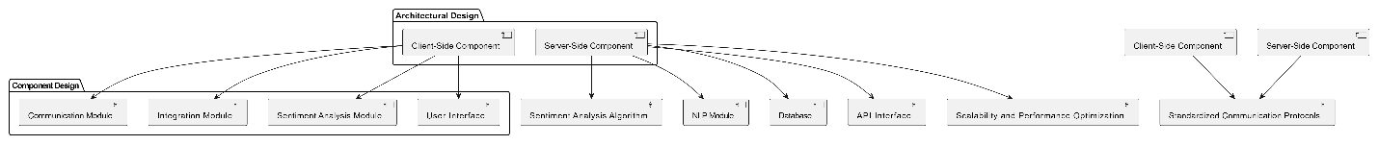

## **Components Designs and Components descriptions**

The proposed system consists of the following components:

* **Text Parser:** Extracts text content from web pages for analysis.
* **Sentiment Analysis Engine:** Uses NLP libraries and APIs to determine the sentiment of the extracted text.
* **UI Renderer:** Displays sentiment results to the user in a clear and intuitive manner.
* **Settings Manager:** Allows users to configure the extension’s behavior according to their preferences.
* **Feedback Loop:** Collects user feedback to continuously improve the accuracy and usability of the system.

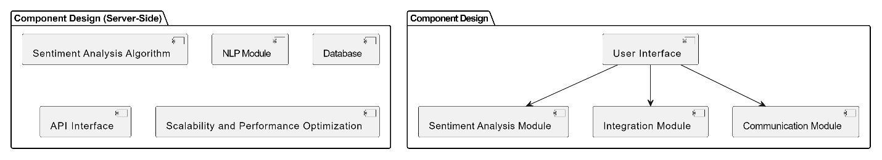

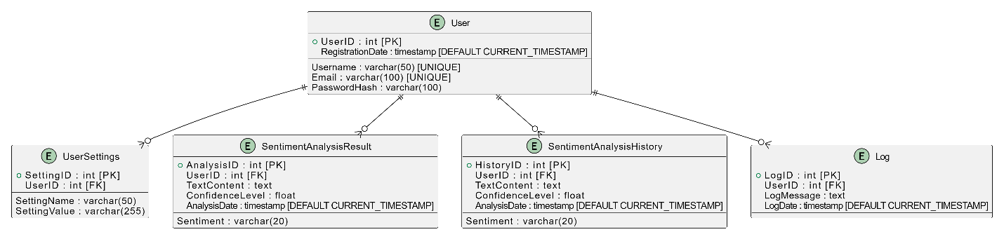

## **Proposed system/software features**

The proposed browser extension will offer the following features:

* **Real-Time Sentiment Analysis:** Provides instantaneous sentiment scores for text content as users browse the web.
* **Customizable Settings:** Allows users to adjust analysis frequency, sentiment thresholds, and display options.
* **User-Friendly Interface:** Features an intuitive UI with clear visualizations of sentiment data.
* **Cross-Browser Compatibility:** Ensures seamless operation across popular web browsers, including Chrome, Firefox, and Edge.
* **Privacy Controls:** Includes options for users to manage data privacy and consent, in compliance with regulations like GDPR and CCPA.

## **Development tools and environment (a brief write up about the tools and environment to be used for the project implementation**

* **HTML, and CSS, and JavaScript:** Used structuring and styling the user interface of the extension, and for building the frontend components and interactions of the browser extension.

* **Browser Extension Framework:** This includes frameworks like Chrome Extension API, Firefox WebExtensions API, or Microsoft Edge Extension API, which are essential for integrating the extension with different web browsers.

* **Natural Language Processing (NLP) Libraries:** NLTK (Natural Language Toolkit), spaCy, or TensorFlow: These libraries are crucial for performing sentiment analysis, text processing, and implementing machine learning tasks within the extension.

* **Sentiment Analysis APIs:** Google Cloud Natural Language API, IBM Watson Natural Language Understanding, or TextBlob: These APIs provide pre-trained sentiment analysis models and advanced NLP features, ensuring accurate sentiment classification in real-time.

* **Integrated Development Environments (IDEs):** Visual Studio Code, Sublime Text, or JetBrains WebStorm: IDEs facilitate coding, testing, and debugging the browser extension code, ensuring smooth development workflow.

* **Version Control Systems:** (Eg: Git) Used for collaborative development, version tracking, and code management, ensuring seamless collaboration among team members.

* **Hosting Platforms:** Platforms like GitHub, GitLab, or Bitbucket are used for hosting the project repository and enabling efficient collaboration.

* **Testing and Quality Assurance Tools:** Jasmine, Mocha, or Jest: These testing frameworks are essential for writing and executing unit tests, integration tests, and end-to-end tests to ensure the reliability and robustness of the extension.

* **Browser Developer Tools:** Built-in tools provided by web browsers (e.g., Chrome DevTools, Firefox Developer Tools) are used for inspecting and debugging frontend components and code.

* **Documentation Tools:** Markdown, Sphinx, or DocBook: These tools are utilized for creating comprehensive user documentation, developer guides, and API references, ensuring that users and developers can understand and utilize the extension effectively.

* **User Feedback and Analytics Tools:** User feedback tools (e.g., UserVoice, UserReport) and analytics platforms (e.g., Google Analytics, Mixpanel): These tools are crucial for collecting user feedback, analyzing user engagement, and monitoring usage patterns to improve the functionality and user experience of the extension.

* **Privacy and Compliance Tools:** Privacy policies, cookie consent banners, and data protection measures: These tools are implemented within the extension to ensure compliance with privacy regulations such as GDPR and CCPA, safeguarding user data and privacy.

* **Computer or Laptop:** A computer or laptop with sufficient processing power and memory to run the development tools, IDEs, and browsers smoothly.

* **Internet Connection:** An internet connection is necessary for accessing online resources, APIs, collaboration tools, and for testing the extension across different browsers.

* **Web Browser:** Various web browsers (e.g., Google Chrome, Mozilla Firefox, Microsoft Edge) are required for testing and deploying the browser extension, ensuring compatibility and usability across different platforms.

## **Benefits of implementation of the proposed system**

The project's value proposition lies in its ability to provide real-time sentiment analysis directly within the browsing experience, offering users a seamless and intuitive solution for extracting valuable insights from online content. The key aspects of the value proposition include:

* Instantaneous Insights: The browser extension offers instantaneous sentiment analysis as users browse the web, allowing them to quickly assess the emotional tone and sentiment of textual content encountered online without the need for manual analysis or external tools.

* Enhanced Decision-Making: By providing timely insights into sentiment trends and patterns, the browser extension empowers users to make informed decisions across various domains, including marketing, customer service, finance, and politics, enabling them to capitalize on opportunities and mitigate risks effectively.

* User-Friendly Interface: The browser extension features an intuitive interface with user-friendly features and customization options, ensuring a seamless and enjoyable user experience for individuals and professionals alike, regardless of their technical expertise.

* Accurate Analysis: Leveraging advanced natural language processing (NLP) techniques and sentiment analysis algorithms, the extension delivers accurate sentiment classification results, enabling users to trust the reliability and validity of the insights generated.

* Versatility and Adaptability: The browser extension caters to a diverse range of users and use cases across industries, offering versatility and adaptability to meet the unique needs and requirements of different user groups and contexts, from marketers and customer service representatives to investors and educators.

* Continuous Improvement: Through iterative development and user feedback mechanisms, the project is committed to continuously improving the functionality, performance, and usability of the browser extension, ensuring that it remains at the forefront of innovation in sentiment analysis technology.

# **METHODOLOGY**

## **Chapter Overview**

This chapter outlines the methodology used in the development of the AI Sentiment Analyzer browser extension. It covers the requirement specifications, stakeholder identification, requirement gathering process, functional and non-functional requirements, system design, and the project management approach. The methodology ensures that the project is executed systematically, addressing all critical aspects to achieve the desired outcomes.

## **Requirement specification**

The requirement specification defines the functionalities and characteristics that the AI Sentiment Analyzer browser extension must fulfill. It serves as a blueprint, ensuring that the final product meets the expectations of stakeholders and users.

### Requirement Gathering

The process starts with gathering all the necessary requirements from stakeholders. This can be done through interviews, surveys, workshops, observations, and studying existing systems or documentation.

### • Documentation

The gathered requirements are then documented in a structured format, often as a Software Requirement Specification (SRS) document. This document includes both functional requirements (specific behaviors or functions) and non-functional requirements (performance, security, usability, etc.).

### • Requirement Analysis

The requirements are analyzed to ensure they are clear, complete, consistent, and feasible. This may involve resolving conflicts between requirements, prioritizing them, and identifying any potential issues that could affect the project.

### • Validation and Verification

Once documented, the requirements are validated with the stakeholders to ensure they accurately reflect the needs of the system. This step ensures that all parties have a common understanding of what the system is supposed to do.

## **Stake holders of system**

The stakeholders of the AI Sentiment Analyzer browser extension include:

* **End Users**: Individuals who will use the extension to analyze the sentiment of text within their web browsers. This could include marketers, content creators, customer service representatives, and everyday internet users.
* **Project Developers**: The team responsible for designing, developing, testing, and maintaining the extension.
* **Project Manager**: The person overseeing the project, ensuring that it stays on track in terms of timeline, budget, and scope.
* **Business Analysts**: Professionals who identify the business needs and ensure that the extension aligns with those needs.
* **Quality Assurance Team**: Responsible for testing the extension to ensure it meets the specified requirements and is free of bugs.
* **Technical Support Team**: Provides assistance to end users experiencing issues with the extension.
* **Data Privacy Officers**: Ensures that the extension complies with data protection regulations, such as GDPR and CCPA.

## **Requirement Gathering process**

The requirement gathering process involves several stages to ensure that the project captures all necessary functionalities and constraints:

* **Interviews and Surveys**: Conducted with potential users to understand their needs, preferences, and pain points related to sentiment analysis tools.
* **Market Analysis**: Studied existing sentiment analysis tools and browser extensions to identify gaps in the market that the AI Sentiment Analyzer can fill.
* **Brainstorming Sessions**: Held with the development team to brainstorm features and functionalities that could enhance the user experience.
* **Requirement Documentation**: All gathered requirements are documented, reviewed, and approved by stakeholders before moving forward with the development process.

## **Functional requirements**

### **Functional User Requirements**

* Users shall highlight, select, or input data within a web page.
* User shall select option for data to be analyzed.
* The system shall analyze the selected data for sentiment.
* The system shall identify whether it is positive, negative, or neutral.
* Users shall have the option to view the sentiment analysis results displayed alongside the selected text.
* The system shall provide an overall sentiment score for the selected text, indicating the intensity of the sentiment expressed.
* Users shall to customize the sentiment analysis settings, such as choosing the language or sentiment analysis model used.
* The system shall support real-time sentiment analysis, updating the results dynamically as the user selects different text.

### **Functional System Requirements:**

* Implement a text selection feature that allows users to highlight text within a web page.
* Integrate a sentiment analysis algorithm capable of analyzing the sentiment of the selected text.
* Develop a user interface component to display the sentiment analysis results alongside the selected text.
* Implement an algorithm to calculate an overall sentiment score based on the sentiment analysis results.
* Create a settings menu to allow users to customize the sentiment analysis settings, such as language and model selection.
* Implement real-time updating functionality to continuously analyze selected text and update the sentiment analysis results accordingly.

## **UML Diagrams**

### **Use case diagram for the front-end models**

The use case diagram for the front-end models will illustrate the interactions between the user and the browser extension. Key use cases include text selection, sentiment analysis initiation, result display, and customization of settings.

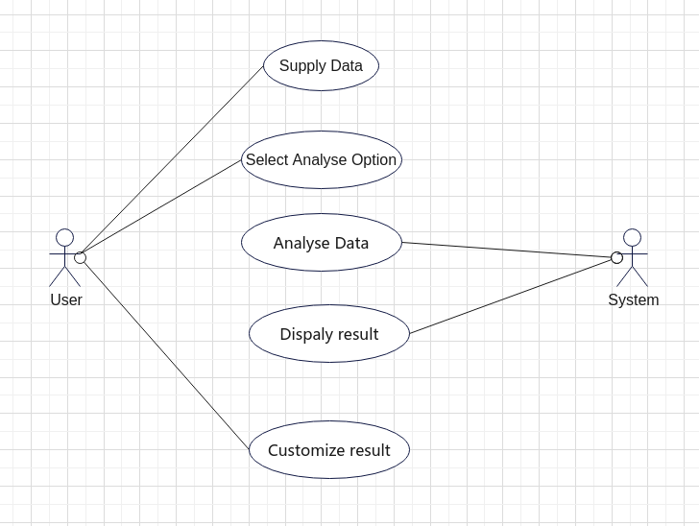

### **Use case diagrams for the back- end model**

The back-end use case diagrams will show how the sentiment analysis algorithm processes the selected text, interacts with external APIs (like Sentigem), and returns the results to the front end for display.

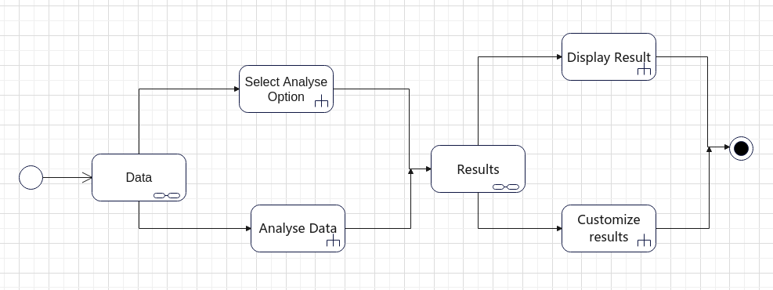

### **Use Case Description For Frontend Use Case Diagram**

* **Actor Roles**: The actors in these use cases include the user (who interacts with the extension), the sentiment analysis API (which processes the text), and the system (which coordinates the data flow).
* **Use Case Descriptions**: Each use case will be described in terms of its goals, steps, and outcomes. For instance, the “Analyze Sentiment” use case will detail how text is selected, processed by the API, and how the results are displayed to the user.

## **Non – functional requirements**

* **Performance**: The system should perform sentiment analysis within a few seconds, ensuring a smooth user experience.
* **Usability**: The extension should have an intuitive interface that requires minimal effort to use.
* **Scalability**: The system should handle multiple simultaneous users without degradation in performance.
* **Reliability**: The sentiment analysis results should be consistent and accurate.
* **Security**: The system must comply with data protection regulations and ensure that user data is not exposed or misused.

## Sequence Diagram

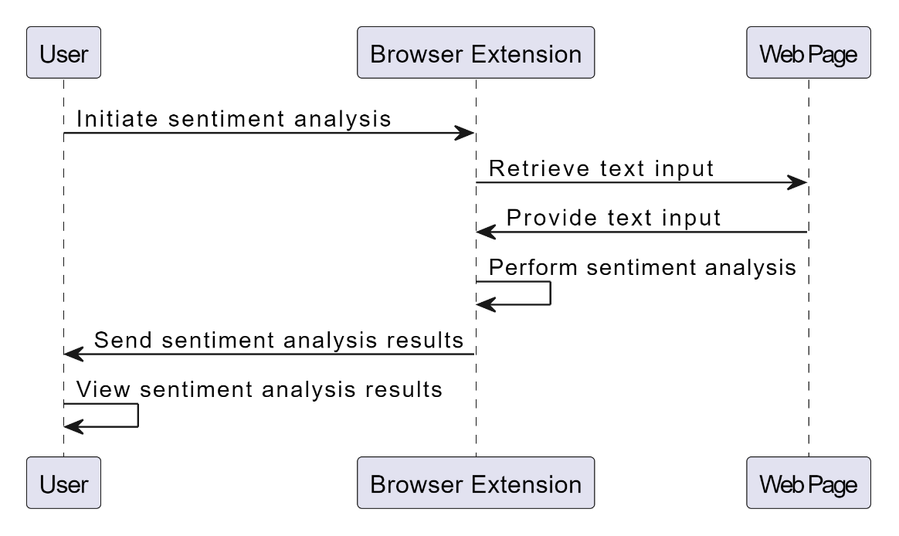

## **Security concepts**

* **Data Encryption**: All user data, including selected text and analysis results, should be encrypted to prevent unauthorized access.
* **Compliance with Regulations**: The extension must comply with GDPR, CCPA, and other relevant data protection regulations.
* **User Consent**: Users must be informed about data usage and provide consent before their text is analyzed.

## **Project methods**

The project will use **Agile methodology**, specifically Scrum, to ensure flexibility, continuous feedback, and iterative development. Agile is chosen because it allows for quick adaptations to changing requirements and encourages active stakeholder involvement throughout the development process.

## **The various software process models**

* **Waterfall Model**: A linear and sequential approach where each phase depends on the deliverables of the previous one.
* **V-Model**: An extension of the waterfall model that emphasizes verification and validation.
* **Iterative Model**: Focuses on refining and improving the product through repeated cycles.
* **Agile Model**: Emphasizes incremental and iterative development, with a focus on customer feedback and flexibility.

## **Chosen model and justification**

The **Agile model** is chosen due to its flexibility and adaptability, which are crucial for developing an innovative product like the AI Sentiment Analyzer browser extension. Agile allows for continuous improvement based on user feedback, ensuring that the final product meets user needs and expectations.

## **PROJECT DESIGN CONSIDERATION (LOGICAL DESIGNS)**

### **UI Design**

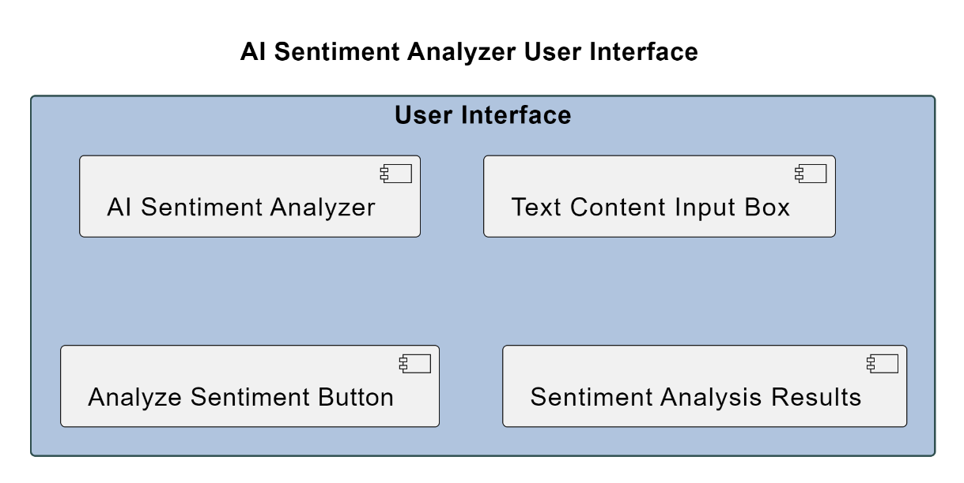

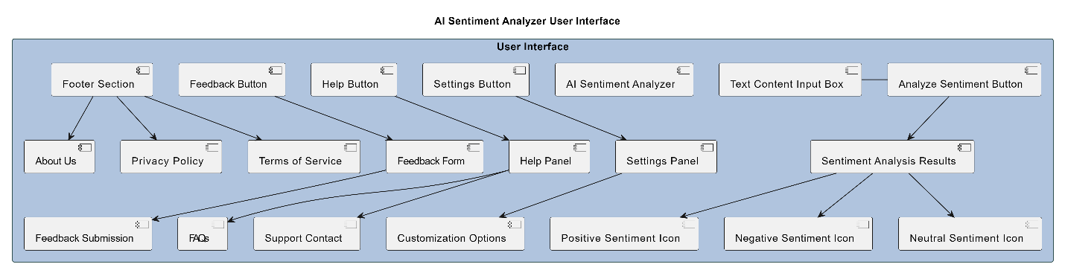

### **Developmental tools**

* **HTML, CSS, JavaScript**: Used for developing the front-end components of the browser extension.
* **NLP library:** Diltilbert
* **Chrome/Firefox WebExtension APIs**: Used to develop the browser extension and ensure compatibility across different browsers.
* **Visual Studio Code**: For coding and debugging.
* **Version Control**: Git will be used for version control, ensuring smooth collaboration and code management.

# **IMPLEMENTATIONS AND RESULTS**

## **Chapter Overview**

This chapter describes the implementation of the AI Sentiment Analyzer browser extension, detailing the construction process, including code snippets and screenshots. It also covers the testing phase, including the testing plan, component testing, system testing, and the results of these tests.

## **Construction**

The core logic of the AI Sentiment Analyzer browser extension involves capturing selected text from the web page, sending it to Sentigem for sentiment analysis, and displaying the results to the user. Below are key code snippets illustrating this process.

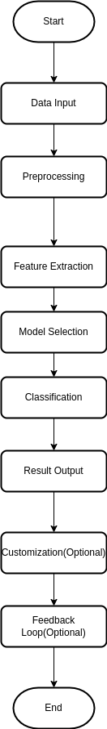

### Snippet 1: content.js (Capturing Selected Text and Showing Hover Button)

// content.js

*let* selectedText = '';

document.addEventListener('mouseup', () *=>* {

    selectedText = window.getSelection().toString().trim();

});

chrome.runtime.onMessage.addListener((*request*, *sender*, *sendResponse*) *=>* {

    if (*request*.action === "analyzeSentiment") {

        if (selectedText) {

            analyzeSentiment(selectedText);

        } else {

            alert("Please select some text to analyze.");

        }

    }

});

*function* analyzeSentiment(*text*) {

    chrome.runtime.sendMessage({action: "analyzeSentiment", text: *text*}, (*response*) *=>* {

        if (*response*.error) {

            alert(`Error: ${*response*.error}`);

        } else {

            displayResult(*response*);

        }

    });

}

*function* displayResult(*result*) {

*const* resultDiv = document.createElement('div');

    resultDiv.style.position = 'fixed';

    resultDiv.style.top = '10px';

    resultDiv.style.right = '10px';

    resultDiv.style.padding = '10px';

    resultDiv.style.backgroundColor = 'white';

    resultDiv.style.border = '1px solid black';

    resultDiv.style.zIndex = '9999';

    resultDiv.innerHTML = `

        <h3>Sentiment Analysis Result</h3>

        <p>Label: ${*result*.label}</p>

        <p>Score: ${*result*.score.toFixed(4)}</p>

    `;

    document.body.appendChild(resultDiv);

    setTimeout(() *=>* resultDiv.remove(), 5000);

}

### Snippet 2: background.js (Processing Request with DistilBERT Model)

// background.js

*const* BACKEND_URL = 'https://sentiment-analyzer-extension.onrender.com';

*function* createContextMenu() {

    chrome.contextMenus.create({

        id: "analyzeSentiment",

        title: "Analyze Sentiment",

        contexts: ["selection"]

    });

}

chrome.runtime.onInstalled.addListener(createContextMenu);

chrome.contextMenus.onClicked.addListener((*info*, *tab*) *=>* {

    if (*info*.menuItemId === "analyzeSentiment") {

        chrome.tabs.sendMessage(*tab*.id, {action: "analyzeSentiment"});

    }

});

chrome.runtime.onMessage.addListener((*request*, *sender*, *sendResponse*) *=>* {

    if (*request*.action === "analyzeSentiment") {

        fetch(`${BACKEND_URL}/analyze`, {

            method: 'POST',

            headers: {

                'Content-Type': 'application/json',

            },

            body: JSON.stringify({text: *request*.text}),

        })

        .then(*response* *=>* *response*.json())

        .then(*data* *=>* sendResponse(*data*))

        .catch(*error* *=>* sendResponse({error: *error*.message}));

        return true; // Keeps the message channel open for the async response

    }

});

chrome.commands.onCommand.addListener((*command*) *=>* {

    if (*command* === "analyze_sentiment") {

        chrome.tabs.query({active: true, currentWindow: true}, (*tabs*) *=>* {

            chrome.tabs.sendMessage(*tabs*[0].id, {action: "analyzeSentiment"});

        });

    }

});

chrome.runtime.onMessage.addListener((*request*, *sender*, *sendResponse*) *=>* {

    if (*request*.action === "submitFeedback") {

        // In a real-world scenario, you'd send this to your backend

        console.log("Feedback received:", *request*.feedback);

        // For now, we'll just simulate a successful submission

        sendResponse({success: true});

    }

});

### Snippet 3: popup.js (Displaying Sentiment Analysis Results)

// popup.js

document.getElementById('analyzeButton').addEventListener('click', () *=>* {

*const* text = document.getElementById('textInput').value;

    if (text) {

        chrome.runtime.sendMessage({action: "analyzeSentiment", text: text}, (*response*) *=>* {

*const* resultDiv = document.getElementById('result');

            if (*response*.error) {

                resultDiv.innerHTML = `<p style="color: red;">Error: ${*response*.error}</p>`;

            } else {

                resultDiv.innerHTML = `

                    <h3>Sentiment Analysis Result</h3>

                    <p>Label: ${*response*.label}</p>

                    <p>Score: ${*response*.score.toFixed(4)}</p>

                `;

            }

        });

    } else {

        alert("Please enter some text to analyze.");

    }

});

document.getElementById('submitFeedback').addEventListener('click', () *=>* {

*const* feedback = document.getElementById('feedbackText').value;

    if (feedback) {

        chrome.runtime.sendMessage({action: "submitFeedback", feedback: feedback}, (*response*) *=>* {

            if (*response*.success) {

                alert("Thank you for your feedback!");

                document.getElementById('feedbackText').value = '';

            } else {

                alert("Error submitting feedback. Please try again.");

            }

        });

    } else {

        alert("Please enter some feedback before submitting.");

    }

});

### Snippet 4: app.py(Flask backend)

import os

import sys

import logging

from flask import Flask, request, jsonify

from flask_cors import CORS

from transformers import AutoTokenizer, AutoModelForSequenceClassification, pipeline

from flask_caching import Cache

# from flask_limiter import Limiter

# from flask_limiter.util import get_remote_address

import sys

try:

    import numpy as np

except ImportError:

    print("Numpy is not installed. Installing now...")

    import subprocess

    subprocess.check_call([sys.executable, "-m", "pip", "install", "numpy"])

    import numpy as np

app = Flask(__name__)

# CORS(app)

CORS(app, *resources*={*r*"/analyze": {"origins": ["chrome-extension://*"]}})

cache = Cache(app, *config*={'CACHE_TYPE': 'simple'})

# limiter = Limiter(key_func=get_remote_address)

# limiter.init_app(app)

logging.basicConfig(*level*=logging.INFO)

logger = logging.getLogger(__name__)

model_name = "distilbert-base-uncased-finetuned-sst-2-english"

tokenizer = AutoTokenizer.from_pretrained(model_name)

model = AutoModelForSequenceClassification.from_pretrained(model_name)

sentiment_analyzer = pipeline("sentiment-analysis", *model*=model, *tokenizer*=tokenizer)

@app.route('/analyze', *methods*=['POST'])

@cache.memoize(*timeout*=300)

# @limiter.limit("100 per day")

*def* analyze_sentiment():

    try:

        text = request.json['text']

        result = sentiment_analyzer(text)[0]

        logger.info(f"Analyzed sentiment for text: {text[:50]}...")

        return jsonify(result)

    except Exception as e:

        logger.error(f"Error analyzing sentiment: {str(e)}")

        return jsonify({"error": str(e)}), 500

if __name__ == '__main__':

    app.run(*host*='0.0.0.0', *port*=int(os.environ.get('PORT', 5000)), *debug*=True)

## **Testing**

### **Testing plan**

### The testing plan for the AI Sentiment Analyzer browser extension involves verifying the functionality of the text selection, sentiment analysis, and result display features. The tests will ensure that the extension correctly captures selected text, analyzes it using the DistilBERT model, and accurately displays the sentiment results.

### **components testing (algorithm for testing UI)**

**Algorithm for Testing UI:**

1. **Verify Button Appearance:** Ensure that the hover button appears when text is selected.
2. **Verify Button Functionality:** Check that clicking the button triggers the sentiment analysis process.
3. **Verify Result Display:** Confirm that sentiment analysis results are displayed correctly next to the selected text.

**Algorithm for Testing Backend:**

1. **Verify Text Processing:** Ensure that the selected text is correctly sent from content.js to background.js.
2. **Verify Sentiment Analysis:** Test that the DistilBERT model correctly processes the text and generates sentiment results.
3. **Verify Result Transmission:** Confirm that sentiment results are sent back to the content script and displayed properly.

### **system testing (algorithm for verification testing, and algorithm for validation testing)**

**Algorithm for Verification Testing:**

1. **Test Text Selection:** Select various texts and verify that the hover button appears and functions correctly.
2. **Test Sentiment Analysis:** Input texts with known sentiment values and verify that the results match expected outcomes.
3. **Test Result Display:** Check that results are accurately displayed in the browser extension UI.

**Algorithm for Validation Testing:**

1. **User Testing:** Conduct testing with real users to validate the extension’s usability and effectiveness in providing sentiment analysis.
2. **Edge Cases:** Test the extension with a variety of text lengths and formats to ensure robustness and reliability.

### **Results**

# **FINDINGS AND CONCLUSION**

## **Chapter Overview**

This chapter presents the findings from the project implementation, discusses the conclusions drawn, and explores the challenges encountered during development. It also reflects on the lessons learned and provides recommendations for future work and commercialization opportunities.

## **Findings**

* **Accuracy of Sentiment Analysis:** The integration of the DistilBERT model into the browser extension has proven effective in analyzing sentiment with a high degree of accuracy. The model’s performance in distinguishing between positive, negative, and neutral sentiments aligns with its expected outcomes.
* **User Interface:** The hover button feature functions well, providing users with a convenient and interactive method to analyze selected text. The extension’s user interface is intuitive, facilitating ease of use without requiring extensive user training.
* **Real-time Analysis:** The system successfully implements real-time sentiment analysis, updating results dynamically as users interact with the extension. This capability enhances the user experience by providing immediate feedback on selected text.
* **Compatibility:** The extension demonstrates good compatibility across major web browsers such as Google Chrome, Mozilla Firefox, and Microsoft Edge. This cross-browser functionality ensures broad accessibility for users.

## **Conclusions**

* **Effective Sentiment Analysis:** The DistilBERT model has effectively met the project's goal of providing accurate sentiment analysis within a browser extension. The model’s integration has enabled real-time processing and reliable sentiment classification.
* **User Experience:** The browser extension’s design effectively meets user needs, providing an easy-to-use tool for analyzing text sentiment directly within the browser. The hover button and results display are well-received features.
* **Technical Feasibility:** The project successfully demonstrates the technical feasibility of integrating a machine learning model into a browser extension. The implementation of DistilBERT within the extension highlights the potential for advanced NLP tools in browser-based applications.

## **Challenges/ limitations of the system**

* **Performance Overhead:** The sentiment analysis process can introduce some performance overhead, particularly with large text selections or on systems with limited resources. Optimizing performance to handle such cases remains a challenge.
* **Model Limitations:** While DistilBERT is effective for general sentiment analysis, it may not capture nuanced sentiments or context-specific nuances as accurately as more specialized models. Further model fine-tuning or customization could enhance accuracy.
* **Browser Compatibility:** Although the extension supports major browsers, occasional compatibility issues may arise with less common or older browser versions. Ensuring consistent performance across all platforms may require additional testing and adjustments.

## **Lesson learnt**

* **Importance of User Feedback:** Incorporating user feedback early in the development process can significantly enhance the usability and effectiveness of the extension. Iterative testing and user input are crucial for refining the user experience.
* **Model Integration Challenges:** Integrating machine learning models into browser extensions presents unique challenges, such as managing performance and ensuring reliable model inference. Careful consideration of these factors is essential for successful implementation.
* **Cross-Browser Development:** Ensuring compatibility across different web browsers requires thorough testing and adaptation. Planning for diverse environments and conducting extensive cross-browser testing are vital for a robust deployment.

## **Recommendations for future works**

* **Model Improvement:** Explore the possibility of fine-tuning the DistilBERT model or experimenting with other sentiment analysis models to improve accuracy and handle more complex sentiment scenarios.
* **Feature Expansion:** Consider adding features such as sentiment trends over time, integration with social media platforms, or additional languages to broaden the extension’s applicability and user base.
* **Performance Optimization:** Investigate methods to optimize performance, such as reducing computational overhead or implementing asynchronous processing to improve responsiveness.
* **User Personalization:** Implement customization options allowing users to tailor sentiment analysis settings based on their preferences or specific use cases.

## **Recommendations for project commercialization**

* **Market Research:** Conduct thorough market research to identify target user segments and understand their needs. This research will inform strategies for positioning and marketing the extension effectively.
* **User Support and Documentation:** Develop comprehensive user support resources, including documentation, tutorials, and customer service channels, to facilitate smooth adoption and usage.
* **Monetization Strategies:** Explore potential monetization strategies, such as offering premium features, subscription models, or partnerships with businesses and educational institutions.
* **Compliance and Privacy:** Ensure that the extension complies with relevant data protection regulations, such as GDPR and CCPA. Implement robust privacy policies and data handling practices to build user trust.

## **References**

* Bird, S., Klein, E., & Loper, E. (2009). Natural Language Processing with Python: Analyzing Text with the Natural Language Toolkit. O'Reilly Media.

* Google Cloud Natural Language API Documentation. Retrieved from: <https://cloud.google.com/natural-language/docs>

* IBM Watson Natural Language Understanding Documentation. Retrieved from: <https://cloud.ibm.com/docs/natural-language-understanding>

* Manning, C. D., Raghavan, P., & Schütze, H. (2008). Introduction to Information Retrieval. Cambridge University Press.

* Mozilla Developer Network (MDN) WebExtensions API Documentation. Retrieved from: <https://developer.mozilla.org/en-US/docs/Mozilla/Add-ons/WebExtensions>

* TensorFlow Documentation. Retrieved from: <https://www.tensorflow.org/api_docs>

* The NLTK Project. Retrieved from: <https://www.nltk.org/>

* The spaCy Project. Retrieved from: <https://spacy.io/>

* "Understanding Sentiment Analysis." IBM. Retrieved from: <https://www.ibm.com/cloud/learn/sentiment-analysis>